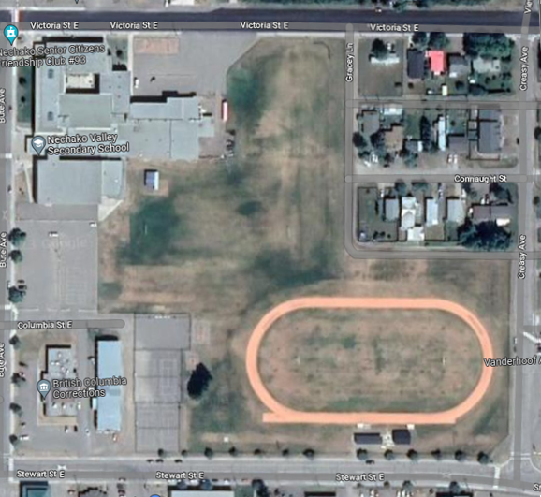

1

2

**NVSS Field**

**U12 Team 1 – Grey**

Coaches: Adrian and Kira

**U12 Team 2 – Yellow**

Coaches: Russ, Adam, and Russell

**Practice times:** Monday and Wednesday 6:00-7:30

May 6 till June 19, 2024

**Pictures: Monday May 27 @6:00**

U12